Trip to Scotland
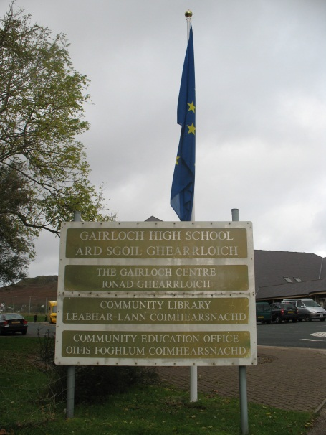
In the morning of 2nd October 2011 everything started….. We all – Aggelos, Panagiota, Spyros and our teacher Mrs Yannakopoulou- met at the airport and flew to the UK.
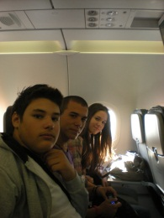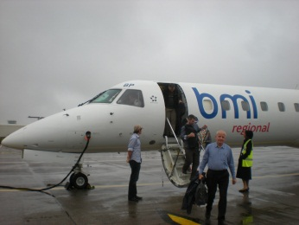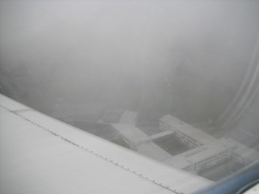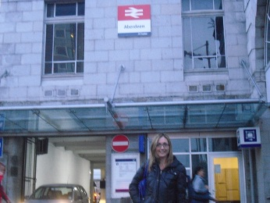
Our first stop was Heathrow airport where we took the flight for Aberdeen. In Aberdeen we went to a big shopping center, watched a catwalk show and had dinner.
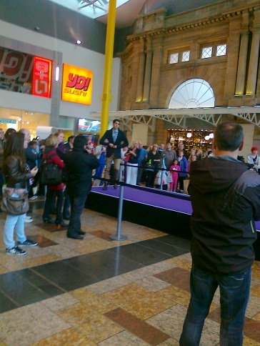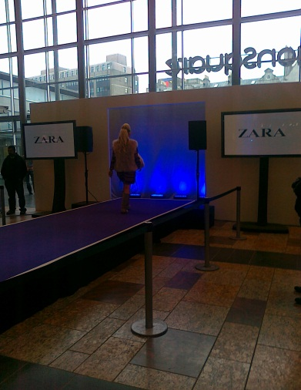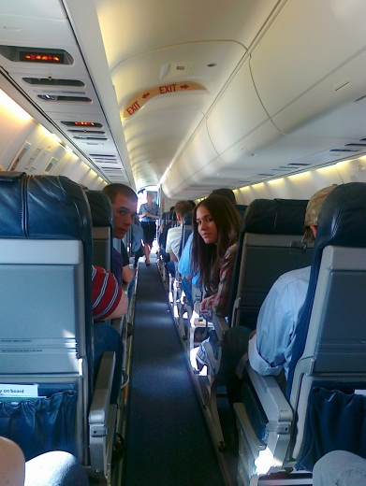
At 9:00 in the evening we took the train to Inverness. We arrived before midnight and went straight to our hotel – The Royal Highland Hotel - where we stayed overnight.
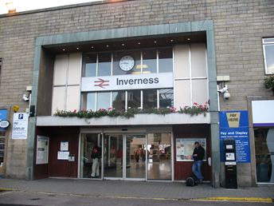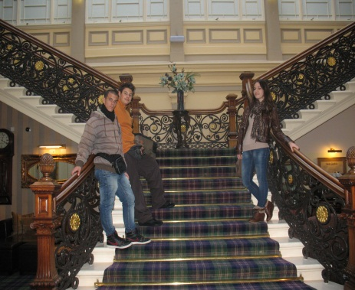
The next day, after having a delicious breakfast we went sightseeing and took photographs.
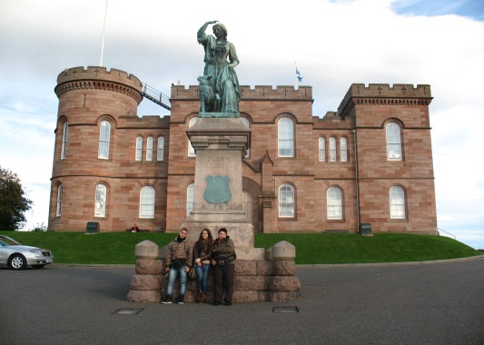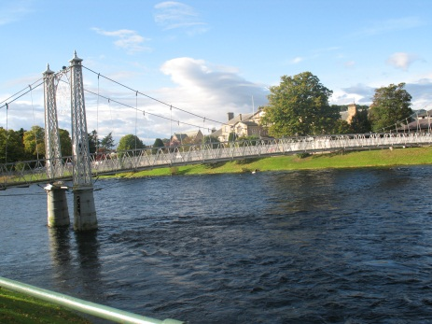
At noon, our friends from Scotland came to take us and give us a lift to Gairloch – our destination. Our Latvian friends came, too.
After a two-hour drive in the school van we finally reached Gairloch. Our host families were waiting for us…
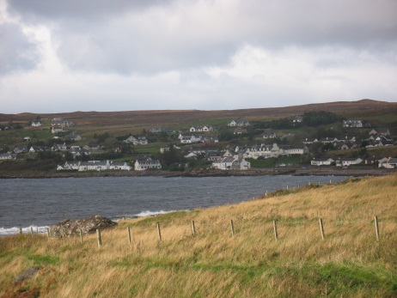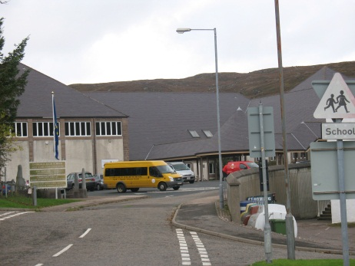
The next day, we met the Italian and the German students and we all had a tour around the school. We even attended lessons there.
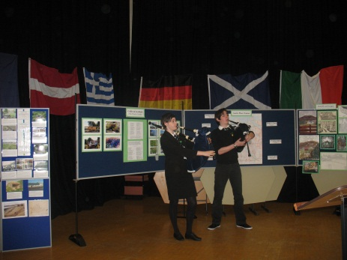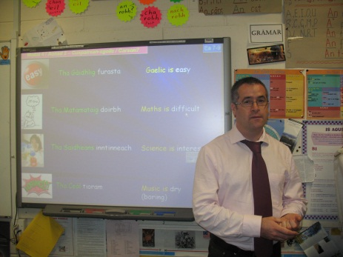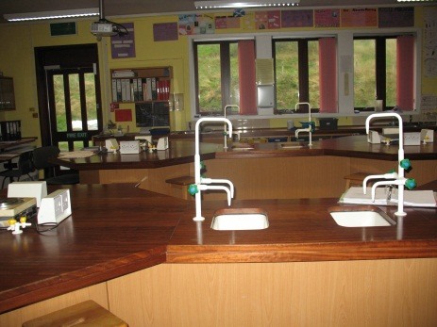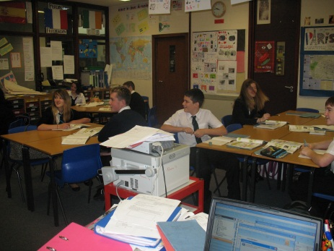
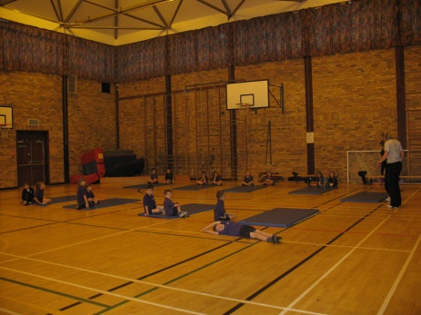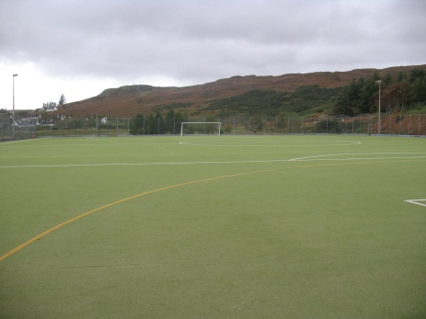
Later, we visited Gairloch Heritage Museum. It presents the story of the heritage and culture of the area from pre-historic times to the present day. The museum is divided into different sections, each one focusing on different aspects of life. Its displays cover many aspects of the history of the area, including archaeological finds, a croft house room, traditional schoolroom, a reconstructed village shop, and the lens of the Rubha Reidh lighthouse.
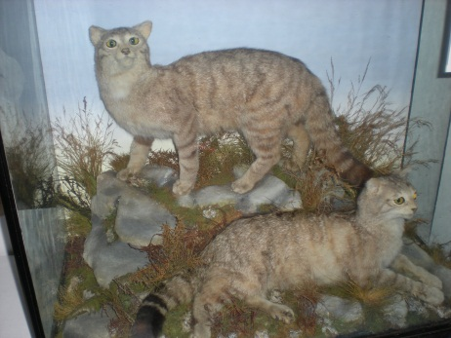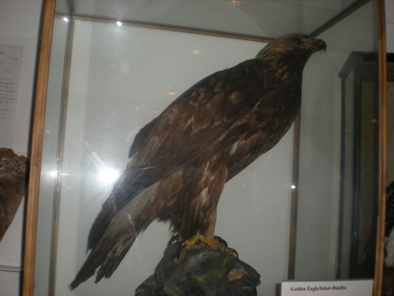
On Wednesday 5th, we went on a bus trip to Culloden Battlefield – a site of defeat in 1746 of Prince Charlie and end of 1745 Jacobite rising. The Battle of Culloden was the final confrontation of the 1745 Jacobite Rising. Taking place on 16 April 1746, the battle pitted the Jacobite forces of Charles Edward Stuart against an army commanded by William Augustus, Duke of Cumberland, loyal to the British government. Our visit included a battle experience in an immersion film battle room. We had lunch at the Museums café and in the afternoon we went to the Loch Ness and the Castle Urquhart where we took photographs.
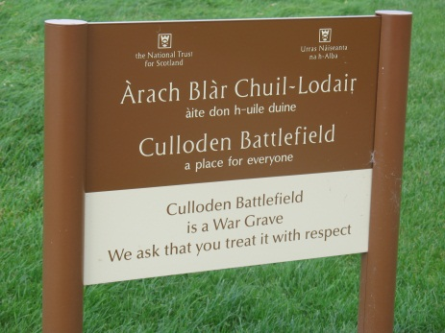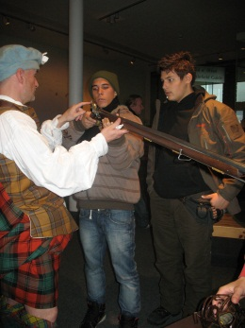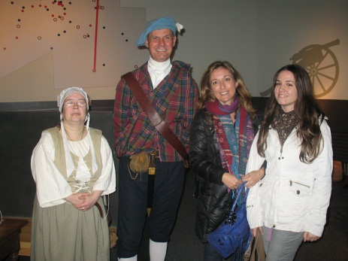
The following day we visited Port Henderson - a fishing village on the south west shore of the Gair Loch near the village of Gairloch, Ross-shire.
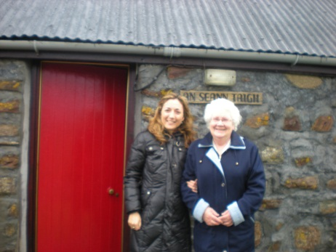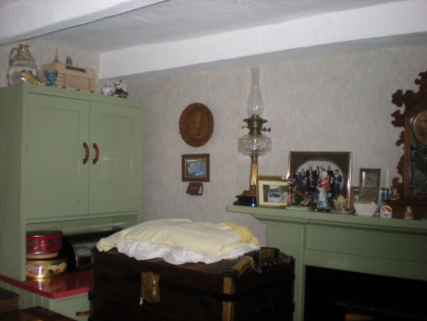
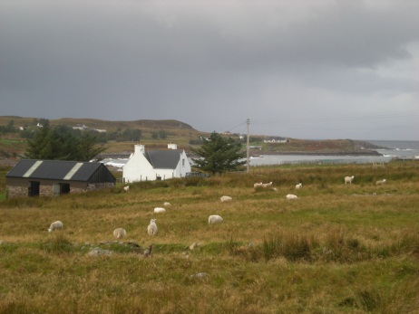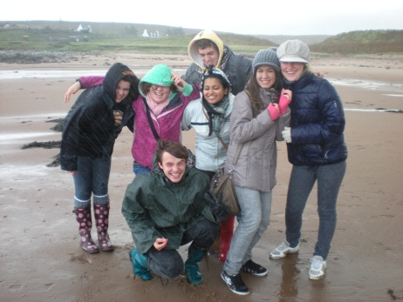
Later on we walked in the Inverewe Garden , a spectacular Highland Garden where a profusion of unusual plants flourish.
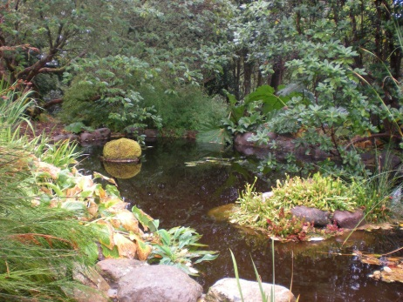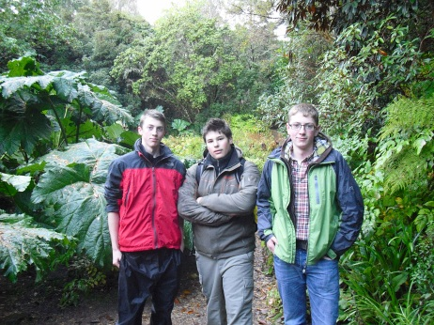

On Friday 7th, in the morning we stayed at school and all the teams showed their presentations.
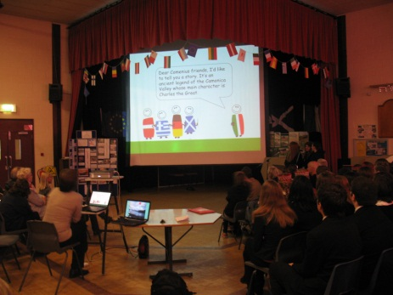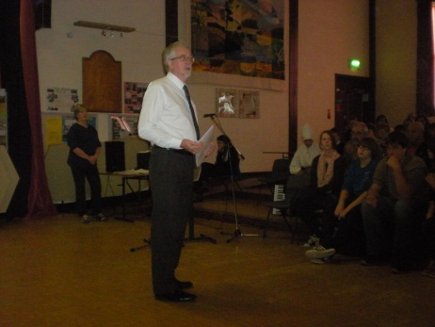

Later, after lunch, we had a Scottish dance practice in the school gym. We had great fun. In the evening we were invited at Ceilidh, a Scottish party, where we danced and played music. Spyros played the bouzouki and Aggelos played the guitar.
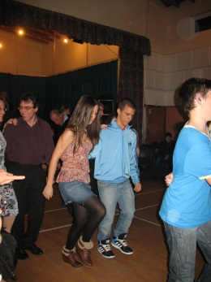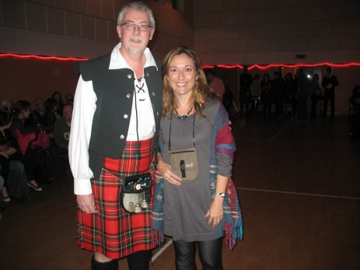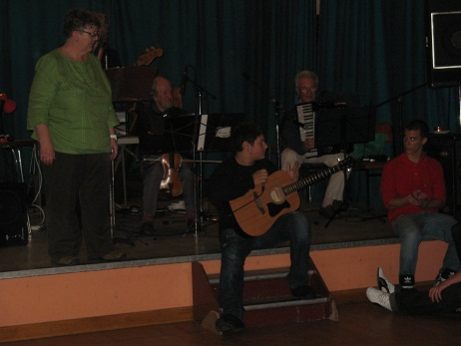
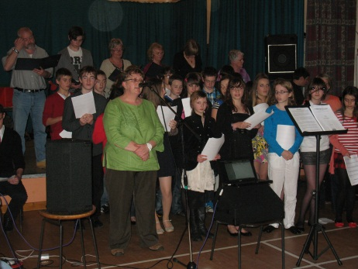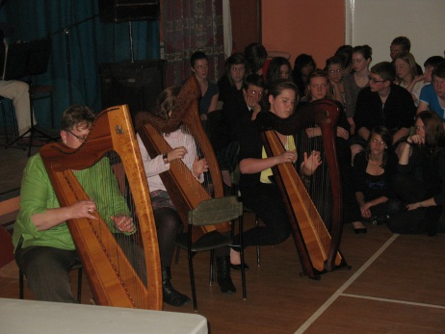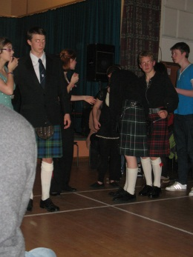
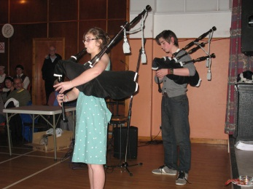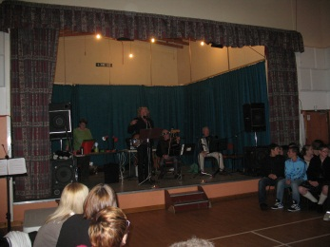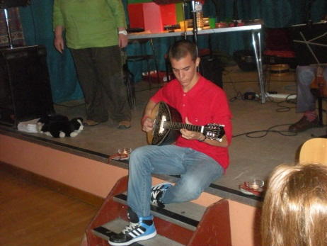
Thank you for everything….. See you in Italy…. and then Athens…
Peggy, Spyros & Aggelos
